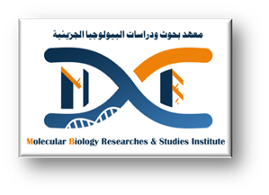


Hasnaa Abdelwahab Mohamed

Demonstrator ( Faculty of medicine, Assiut University, Egypt).

Major Field:- molecular biology

Minor Field:- molecular microbiology

Personal information

Place and date of Birth
Mankabad, Assiut, Friday 27th June 1997

Address
Molecular biology and research institute Assiut, Egypt.

Email
Hasnaa.alhussein1@gmail.com
Hasnaa_26.aun.edu.eg

Telephone
+0020882399475 (Home) +01112671186(Mob.)

Nationality
Egyptian

Content

Academic education

2015-2023 student at faculty of medicine , Assuit University

Academic positions

2023 till now demonstrator of molecular microbiology at molecular biology research and studies institute Assuit University

Language skills:

Arabic native language
English good
Germany limited
French limited knowledge
Japanese limited knowledge

Computer Skills:

ICDL/ECDL Certified
.

4. Workshops, Scientific Visits and Additional Skills

Workshops:
1- cell and tissue culture workshop 23-25 Oct 2023 (3 days).
- mesenchymal stem cells isolation and characterization 5-6 December 2023(3 days).
- DNA Extraction and PCR applications 17-18 April 2024
- Basics of flow cytometry 12 december 2024(1day)
- Basics of scientific research 26 Feb 2024 (7weeks)
- SDS Page Basics 2-3 April 2024(3days)

5. Research Expoereince, Conferences/Presentations and awards

Research Expoereince

<((((º> ><((((º> ><((((º> ><((((º> ><((((º> ><((((º> ><((((º> ><((((º> ><((((º> ><((((º>><((((º>><((((º> ><((((º> ><((((º>><((((º>

